USER'S INSTRUCTION MANUAL

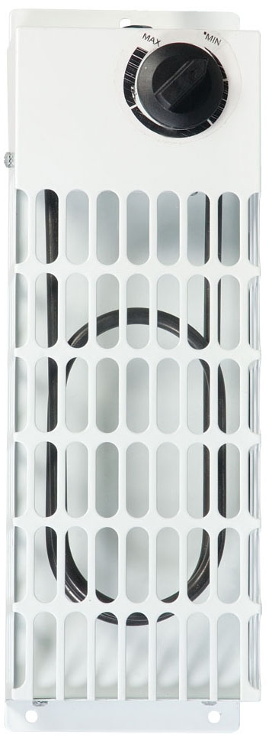

Radiant Heater

RH01A
IP 24

Local space heater specified for purpose other than indoor space heating to reach
and maintain a certain thermal comfort of human beings by means of heat
convection or heating radiation.

Ningbo Joyee Electrical Appliances Co., Ltd.
East Industry Development Area, Guanhaiwei, Cixi, Zhejiang, China

Please read the instruction below before use the heater.
1. Important
1). Assure the power is according to the heater requirement, and the metal housing must be with Earth validly.
2). Do not roast anything on the housing cover to avoid damage the heating element cover and effect the product life, and do not use taper things to blow the component.
3). It should use at the voltage AC 220V-240V.
4). Do not adjust the thermostat new for every use.
5). Please use a safe aid tools like a safe ladder for climbing if you need to adjust the thermostat, Do not use a unsafe aid like a chair or table，unplug if not use for a long time.
6).The socket-outlet shall be installed near the equipment and shall be easily accessible.
2. Product Instruction
The heater use the waterproof heating element, it with high heat efficiency, quick temperature rising, no noise, long use life, safe and credible.
3. Technology Data
Voltage: AC 220V-240V
Frequency: 50-60Hz
Power: 200W
Class I
4. Important Safeguards
- Ensure the power fit to the rating power, the exterior metal must be grounded.
- Insulating resistance must be checked before first Using. Insulating resistance at least 1M ohm. If long time no using or improper keeping will down the insulation, please dry it to resume using.
- Do not roast anything on the surface to avoid polluting the surface of heating component which will cause the lifetime of component. Do not scrape the component.
- Put the Heater upright, smooth. Do not make it inversion or gradient.
- Keep the Power off when maintaining.
- The fan heater is not suitable for use outdoors in damp weather, in bathrooms or in other wet or damp environments.
- Please note that the fan heater can become very hot and should, therefore, be placed at a safe distance from flammable objects such as furniture, curtains and similar.
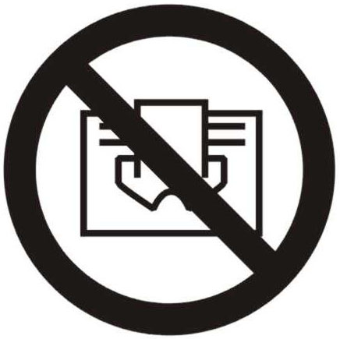
- WARNING: In order to avoid overheating, do not cover the fan heater.

- The fan heater must not be located immediately below a socket-outlet.
- Do not connect the fan heater using an on/off timer or other equipment which can automatically switch the device on.
- The fan heater must not be placed in rooms where flammable liquids or gases are used or stored.
- If an extension cord is used, it must be as short as possible and always be fully extended.
- You must not connect other appliances to the same mains socket as the fan heater.
- Do not use this heater in the immediate surroundings of a bath, a shower or a swimming pool.
- If the supply cord is damaged, it must be replaced by the manufacturer or its service agent or a similarly qualified person in order to avoid a hazard.
- If the appliance is used for industrial position, it only be used by laymen in the shops, in light industry and on farms
- This appliance can be used by children aged from 8 years and above and persons with reduced physical, sensory or mental capabilities or lack of experience and knowledge if they have been given supervision or instruction concerning use of the appliance in a safe way and understand the hazards involved.
- Children shall not play with the appliance. Cleaning and user maintenance shall not be made by children without supervision.
- Children of less than 3 years should be kept away unless continuously supervised.
- Children aged from 3 years and less than 8 years shall only switch on/off the appliance provided that it has been placed or installed in its intended normal operating position and they have been given supervision or instruction concerning use of the appliance in a safe way and understand the hazards involved. Children aged from 3 years and less than 8 years shall not plug in, regulate and clean the appliance or perform user maintenance.
- CAUTION — Some parts of this product can become very hot and cause burns. Particular attention has to be given where children and vulnerable people are present.
5. Installation
1>.wall mounted vertically.
2>.the position of the wall mounted (see picture 1).
3>.The heater must be installed at least 6cm above the floor.

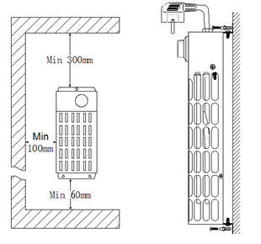
Picture 1
Warranty Information
The manufacturer provides warranty in accordance with the legislation of the customer's own country of residence, with a minimum of 1 year (Germany: 2 years), starting from the date on which the appliance is sold to the end user.
The warranty only covers defects in material or workmanship.
The repairs under warranty may only be carried out by an authorized service centre. When making a claim under the warranty, the original bill of purchase (with purchase date) must be submitted.
The warranty will not apply in cases of:
- Normal wear and tear
- Incorrect use, e.g. overloading of the appliance, use of non-approved accessories
- Use of force, damage caused by external influences
- Damage caused by non-observance of the user manual, e.g. connection to an unsuitable mains supply or non-compliance with the installation instructions
- Partially or completely dismantled appliances
Correct Disposal of this product
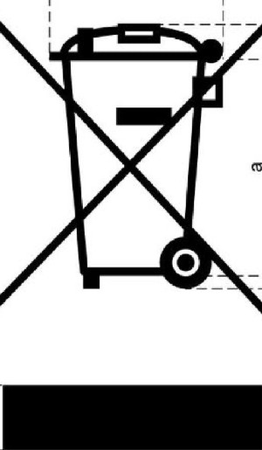
This marking indicates that this product should not be disposed with other household wastes throughout the EU. To prevent possible harm to the environment or human health from uncontrolled waste disposal, recycle it responsibly to promote the sustainable reuse of material resources. To return your used device, please use the return and collection systems or contact the retailer where the product was purchased. They can take this product for environmental safe recycling.

